**61.How Scenario Outline works?**

**Suppose if we want to check login is successful for all three possible types of inputs , which are username , password ,email address or phone number**

**We use Scenario outline Example keyword**

Scenario Outline : Login message with valid credentials

Given User on Facebook Login page

When User enter valid “<username>” and “<password>” (“<username >” this is called placeholder)

Then user successfully login on Facebook

**Examples**

|username| password|

|subburu|test123| – place holder values

|[subburusravan@gmail.com](mailto:subburusravan@gmail.com)| test123|

|8008068547|test123|

**62.When to use Scenario Outline ?**

**Working of Scenario Outline**

**Scenario Outline cannot be used without Examples**

a)Scenario Outline is a template that never runs directly , It uses placeholders which contained within <> in the Scenario Outline Step

b) A Scenario Outline is run for each row in the Examples section (starts from second row,

Leaves first row)

c)As cucumber comes from the scenario outline step that contains <> , it looks for the Examples keyword

d)Cucumber repeats this process for all <> for one round of execution.

**63.How Scenario Outline works that does not have an Examples table ?**

Scenario Outline is useless without Examples table

**64.What will happen if there is no column in Example , for example username , but no username column ?**

If no username not available by default <username > will be taken as it is

Examples

|password|

|Test123||

**65.what will happen if the required column is available in Example , when you want to send a username in the test case?**

It will pick the value from the place holder and provides it to the step definition

**66.What kind of testing is done by scenario Outline?**

**Data driven testing using scenario Outline**

**67.What are the different ways to pass the data in the feature file?**

1.Without using example keyword

2. With Example Keyword

3.By using data tables

**68.How to achieve Data driven testing using cucumber ?**

1.Without using example keyword

2. With Example Keyword

3.By using data tables

**69.Which symbol is used for parameterization in cucumber ?**

Pipe | symbol is used for parameterization in cucumber

**70.what is the difference between Scenario and Scenario Outline?**

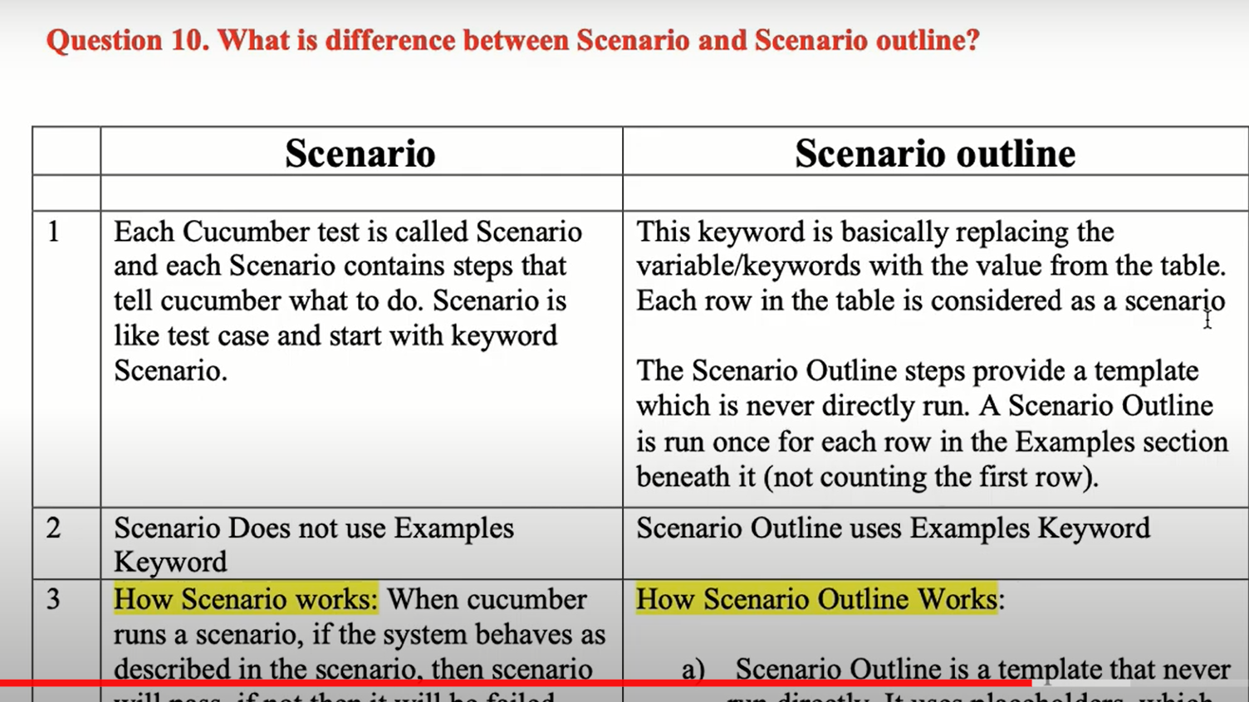

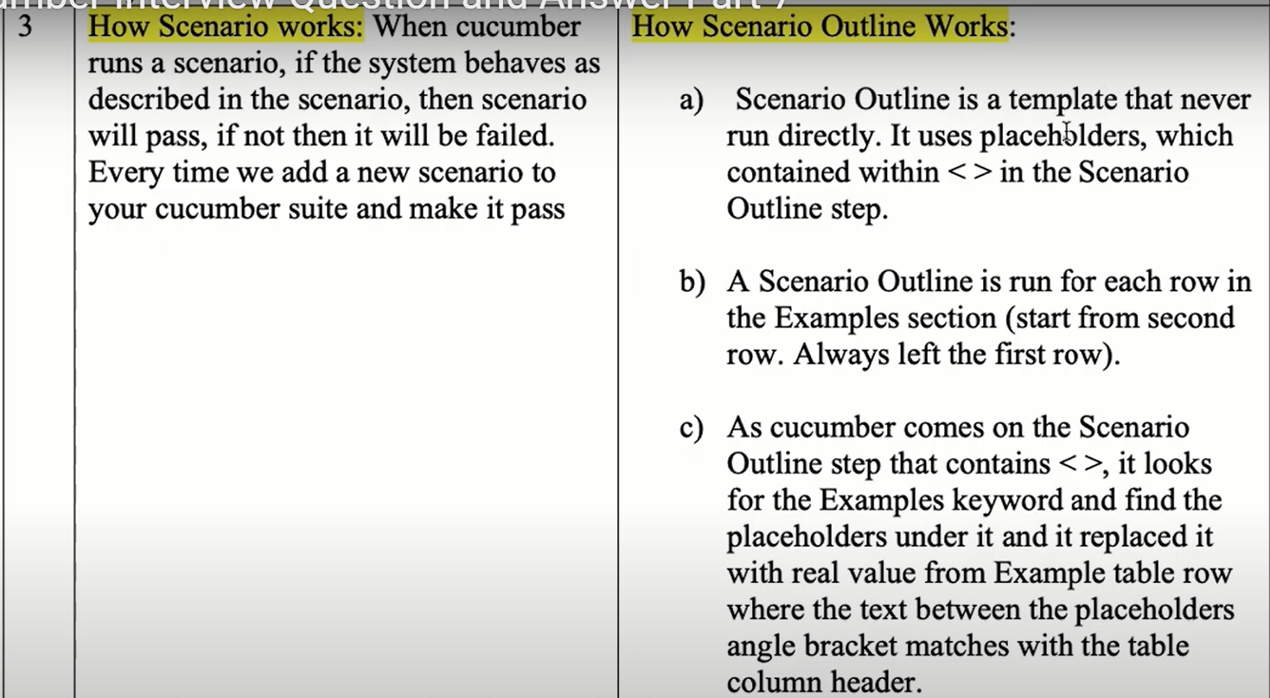

**71. What is Background in Cucumber?**

Background is a keyword used in cucumber to define a step or series of steps that are common to all tests in a feature file , cucumber allows you to add some situation to the scenarios for a feature where it is defined.

Note :

1. A **Background** is much like a scenario containing the number of steps
2. **Background** runs before each scenario for a feature file in which it is defined

**72. What are the Characteristics of Background in Cucumber?**

Background have following Characteristics

1. Only one Background available in one feature line
2. A Background is like a scenario that contains no of steps
3. Background is run before each scenario but after the Before Scenario hook
4. The title of Background is optional
5. Always remain Background must contain common steps of all scenarios
6. Always keep Background short
7. If you ever need to change those steps , you have to change them in one place only

**73. Why do we use Background in Cucumber?**

When we write multiple scenarios in a feature file ,there is possibility of repeated steps in every scenario , so it is better to write the common step in one place

**We use Background to avoid the following problems in the feature file.**

1. Repetition : Many statements are repeated in all the scenarios
2. Duplication : Copying steps to all scenarios is useless
3. Readability : The readability of a feature file is affected
4. Maintenance : Even if a single step changes , then we have to change the step in all Scenarios

**74. How Background works in Cucumber?**

When we write multiple Scenarios in a feature file , then it may be possible that all scenarios have some common steps , these common steps repeat in every scenario. So it is better to write the common steps at one place rather than all scenarios.

**75. What do you pass under Background?**

We pass all common steps of all scenarios under Background

**76. Give an Example of Background in Cucumber?**

**Scenario** : Change Pin successfully

Given I have been issue a new card

When insert the card and enter the correct the PIN

Then select options “Change the pin number “

And change the pin 1234

Then the machine should remember my pin is now 1234

**77. Can we use multiple Backgrounds in a feature file?**

**78. Can we use multiple Backgrounds with Scenario Outline in the feature file?**

No we cannot use multiple Background in feature file

**79. Can we combine Scenario, Background and Scenario Outline in a feature file?**

Yes , we can use Background with Scenario Outline in feature file

**80. What will happen if steps given by you in Background are not common in all Scenarios?**

Yes , we can combine Scenario , Background and Scenario Outline in the feature file.

**81.What will happen if steps given by you in Background are not common for all scenarios ?**

In this case only that scenarios will work that have all common steps given by you in Background

**How Cucumber works with Selenium**

Before knowing the working of cucumber , we must have the knowledge of the following things

1. Components of cucumber
2. Kinds of results can provide by Cucumber
3. What is the meaning of Business Facing code
4. What is Technology Facing code

**Components of Cucumber** :

1. Feature File
2. Step Definition
3. Test Runner Class

**Kinds of result can provide by Cucumbe**r : It can provide following types of result

1. Passed
2. Failed
3. Undefined
4. Pending

**What is the meaning of Business Facing code** : Business Facing code is the section of cucumber which basically focuses on business requirements. It means that information available in this section can be understood by any user , any stakeholder ,BA and any non technical person can easily understand the code available in this section.

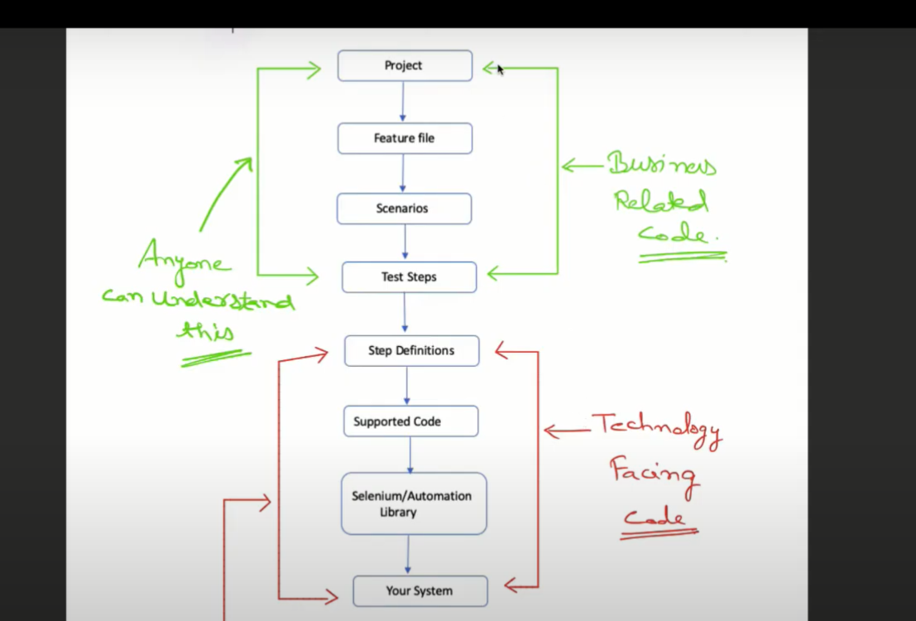

What is the meaning of Technology facing code ?

Technology facing code is the section of cucumber which is basically focus on the coding section. It means that information available in this section cannot be understood by non-technical people.

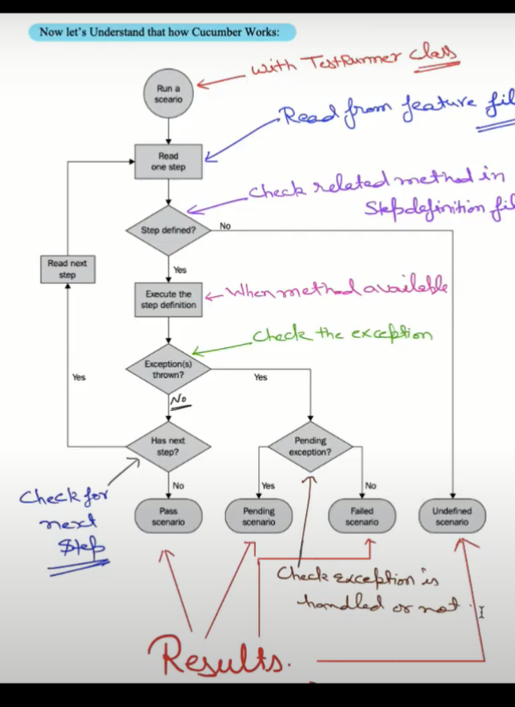

**81. What is a Step Definition file?**

As we know there are three main components of cucumber

1. Feature file
2. Step Definition file
3. Test Runner Class

A step definition is a file where we write our automation code related to feature file

For every scenario written in a file we will write selenium code in step definition file.

We will write a method in step definition file for every step written in a feature file.

There will be one-one mapping between step definition methods and steps written in a feature file.

**82. How to create a Step Definition file?**

1. **Create the step definition package in your framework**
2. **Create the step definition class under this step definition package**

**83. What should a Step Definition file must Contain?**

**a)Selenium code**

**b) java code**

**c) Different annotations**

**84. What is the purpose/use of the Step Definition file in Cucumber?**

The purpose of the step definition file is to provide the code related to feature file steps ,

Each step of the feature file can be mapped to a corresponding method on the step definition file.

**85. What will happen if a Step Definition file does not exist?**

The scenario written in the feature file cannot be executed, No definition found message will be displayed.

**86. What is Test Runner Class?**

Test Runner class is the class that is used to run the feature files. It is a java class having name TestRunner.java

**87. How to create a Test Runner Class?**

SRC folder – Create a class in the runner package and create a class.

TestRunner

**88. What are the different components of the Test Runner Class?**

Test runner class have the following components

1. TestRunner Class
2. @Runwith annotation
3. @cucumberOptions annotations

**89. What is the use of the Test Runner Class?**

1. TestRunner class is the class that is used to run the feature files
2. This class is also used to generate steps
3. It is the test runner class , that you provide the path for both feature file and step definition class
4. With a test runner class , you have the option to run either a single feature file or multiple feature files as well.

**90. Should any code be written within the Test Runner Class?**

No code will be written in TestRunner class

**91. What are the different annotations used in the Test Runner Class?**

TestRunner class has following annotations

1)**@Runwithannotations** : This is often a JUnit annotation that specifies which runner it's to use to execute this class.

2)**@cucumberOptions annotation** : This annotation provides some important information without which we cannot run feature file.

**93.Provide an example of TestRunner class in cucumber ?**

@RunWith(Cucumber.class)

@CucumberOptions(features="src/test/resources/features",

glue= {"steps"},

monochrome=true,

plugin = {"pretty","html:target/HtmlReports"},

tags="@smoketest")

public class TestRunner {

}